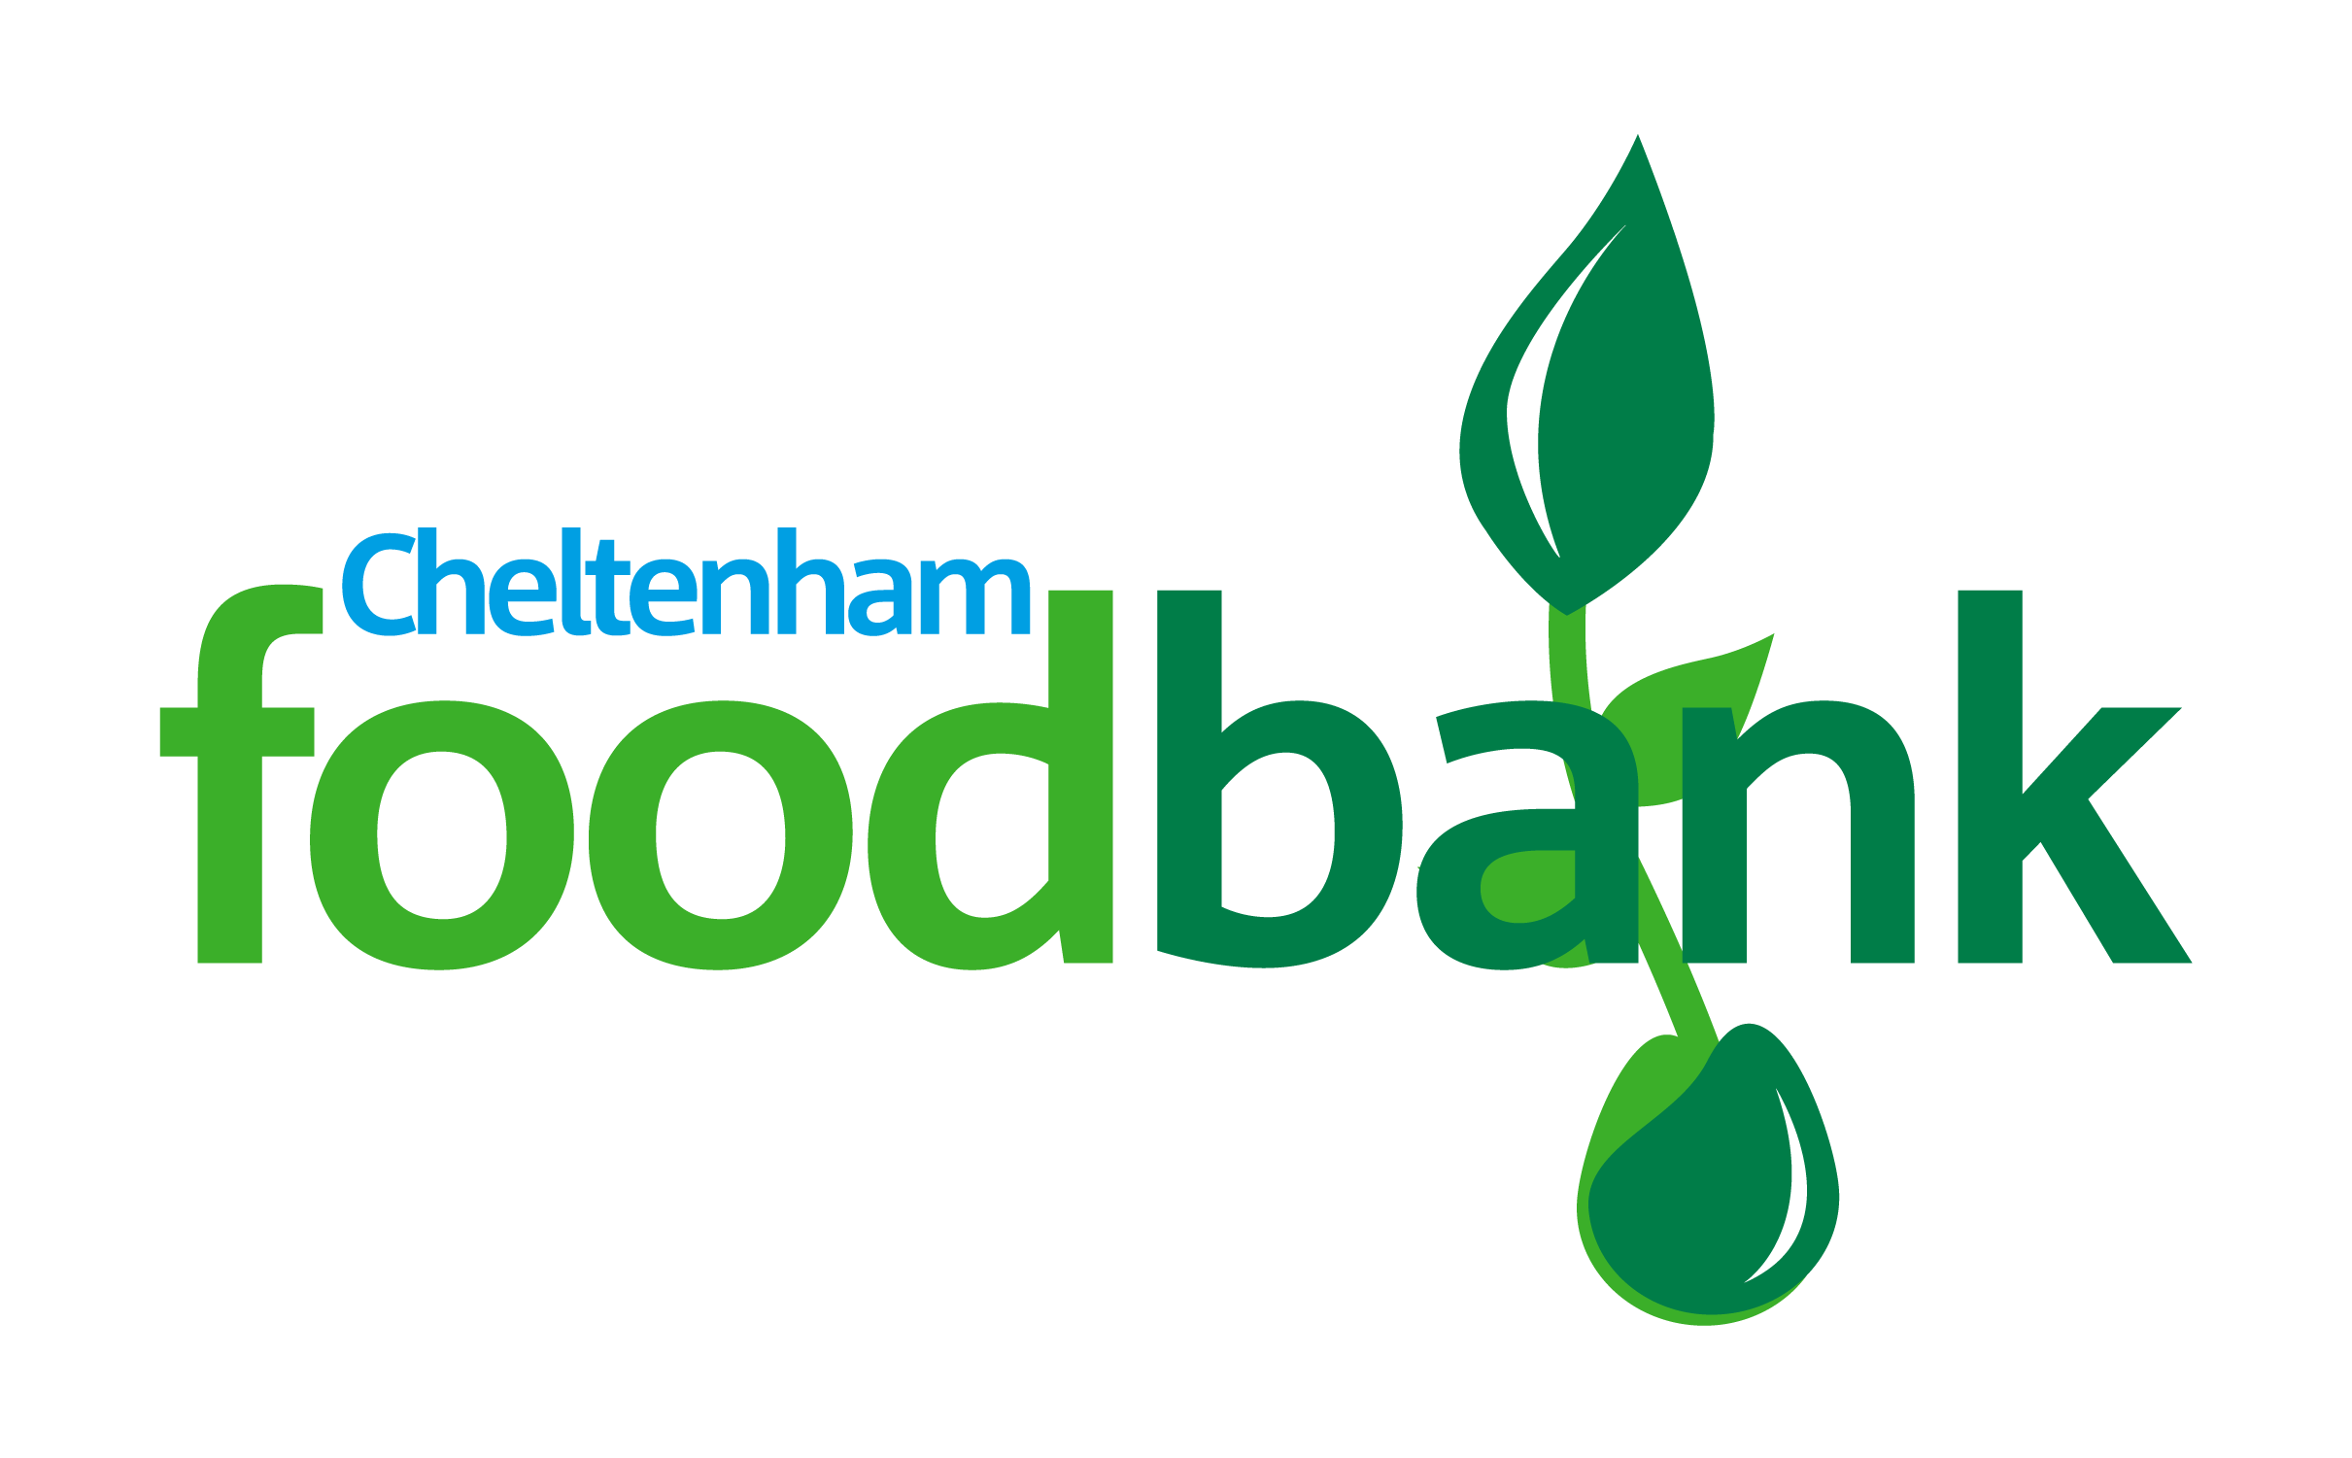
The need for food provision locally is sadly growing and we are busier than ever.
If you are able to help us to fill our shelves here is a list of urgently needed items.
Shaving gel and razors
Deodorant
Toothbrushes and toothpaste
Soup
Instant mash potato
Table sauces
Washing powder capsules
Washing up liquid
Mayonnaise
Tinned fruit
Coffee
Uht milk
Long life fruit juice
Rice pudding / custard
Sponge puddings
Savoury snacks
Sweet snacks and chocolate
Biscuits
Tinned cold meat
Shampoo
Rice pudding
Tinned fruit
THANK YOU FOR YOUR CONTINUED SUPPORT AND GENEROSITY
LOCAL PEOPLE SUPPORTING LOCAL PEOPLE IN CRISIS

